### Chapter 3 – Imaging

The mammalian hippocampus is considered important in the formation of new memories about experienced events (episodic or autobiographical memory), general declarative memory (memories that can be explicitly verbalized), spatial memory and navigation, and associations between stimuli that are distinct in time, among other functions. To achieve this, the Hippocampus must integrate information from different areas of the cortex.

Much of the cortical information that enters the Hippocampus (Dentate Gyrus, specifically) comes through the Entorhinal Cortex, along the Perforant Path (Hjorth-Simonsen, A., 1972). The Dentate Gyrus cell network then relays this information to the CA3 cell network through Mossy Fibers, which in turn relays the information to CA1 cells, through the Schaffer Collateral Fibers. This is popularly known as the Trisynaptic Circuit and there is scope and evidence for computation and information processing at every step (McHugh et al., 2007; Nakashiba et al., 2008; Suh et al., 2011; MacDonald et al., 2012; Modi et al., 2014). Finally, the CA1 cells have their outputs to other brain regions. It is important to note, however, that regions like the CA1 are known to have access to information directly from other brain regions, as well (cited from “The Hippocampus Book”).

Literature in the field suggests that naïve animals may have some sensory gating of “Neutral” stimuli at the level of the CA1 (Kamondi et al., 1998; Bellistri et al., 2013; Abe et al., 2014). The source of this inhibition (at least the step before the local interneurons) seems to be the Medial Septum, through Fimbria-Fornix (Abe et al., 2014). Also, behavioural relevance allows the CA1 to elicit depolarizations (Pastalkova et al., 2008; Harvey et al.., 2009; Itskov et al., 2011 & 2012; MacDonald et al. 2011 & 2013; Dombeck et al., 2010; Modi et al., 2014).

The Hippocampus consists of ventral and dorsal portions both of which are of similar composition but are parts of different neural circuits (Moser and Moser, 1998). Fanselow et al., 2010 reviewed that it is the dorsal hippocampus that performs primarily cognitive functions and in memory function, while the ventral hippocampus modulates emotional and affective processes.

We now discuss the in vivo Hippocampal preparation, physiology recordings, and a brief summary of the results.

Overall Project Aim

To study how sensory stimulus responses of Hippocampal CA1 develop with associative learning.

Physiology and Anatomy of the Hippocampus

My experiments deal with studying (through imaging) the representation of real-world stimuli in a network of dorsal CA1 cells of the Hippocampus of head-fixed male C57BL/6 mice. The objective is to then understand the network-level and cellular phenomenon, involved when associations are made, by studying whether and how stimulus representations, in terms of the spatio-temporal activity of CA1 neurons, change with learning.

The Hippocampus is located deep in the medial temporal lobe of mammals and is defined by several sub-structures, including the Dentate Gyrus (one site for information input to the hippocampus) and the Hippocampus Proper constituted by the CA1, CA2, CA3 and CA4 cellular levels.

Much of the cortical information that enters the Hippocampus (Dentate Gyrus, specifically) comes through the Entorhinal Cortex, along the Perforant Path (Hjörth-Simonsen, A., 1972). The Dentage Gyri cell network then relays this information to the CA3 cell network through Mossy Fibers, which in turn relays the information to CA1 cells, through the Schaffer Collateral Fibers. This is popularly known as the Trisynaptic Circuit and there is scope for computation and information processing at every step. Finally, the CA1 cells have their outputs to other brain regions. It is important to note, however, that regions like the CA1 are known to have access to information directly from other brain regions, as well (cited from “The Hippocampus Book”).

The Hippocampus consists of ventral and dorsal portions both of which are of similar composition but are parts of different neural circuits (Moser and Moser, 1998).

The two main subdivisions of the Entorhinal Cortex, the Lateral and Medial Entorhinal Areas differently and exclusively project to the Septal (dorsal) and Temporal (ventral) levels of the dentate gyrus, respectively (Hjörth-Simonsen, A., 1972; Ruth et al., 1982 and 1988; Dolorfo and Amaral, 1998).

Vinogradova et al. (2011) reported that only the Medial Entorhinal Area (projects exclusively to the ventral hippocampus) was a truly poly modal structure, vigorously responding to auditory, visual and somatosensory stimuli, while the Lateral Entorhinal Area (projects exclusively to the dorsal hippocampus) responded specifically and selectively to tactile stimuli, with only rare, weak and diffuse effects evoked by the stimuli of other modalities.

Interestingly, however, Fanselow et al. (2010) reviewed that it is the dorsal hippocampus that performs primarily cognitive functions and in memory function, while the ventral hippocampus modulates emotional and affective processes. Moreover, Jung et al., 1994 reported that the dorsal hippocampus contains the greatest density and selectivity of place cells coding spatial location. Finally, Zhang and Manahan-Vaughan (2013) showed that the Hippocampus could use non-visuospatial resources (specifically shown using Olfaction), to generate spatial representations.

Using extracellular tungsten microelectrodes, in naïve unanesthetized rabbits serially exposed to multimodal stimuli, Vinogradova et al. showed that in the CA1,

1. Nearly half of the reactive neurons have unimodal responses (41-44%)
2. Multimodal neurons are modality-unspecific but have differentiated responses to stimuli of different modalities and even to various stimuli within a single modality
3. Many neurons respond by Phasic (evoked responses last for the duration and as long as the stimulus) and Specific (stimulus-specific pattern) responses
4. Neurons with inhibitory responses are encountered less frequently than those with various types of excitatory
5. Habituation (non-responsiveness to repeatedly presented stimuli) is present though not among all the responsive cells (71-75%) and is often gradual

Rodents navigating an environment have been shown to elicit landmark tuned CA1 cell firing (O’Keefe and Dostrovsky, 1971) and such “Place Field” specific activity has since been studied in great detail (Leutgeb et al., 2005; Harvey et al., 2009; Dombeck et al., 2010). Separately, the CA1 have also been implicated in memory processes enabling the association of stimuli that are distinct in time (MacDonald et al., 2011 & 2013; Modi et al., 2014).

With regard to stimulus representation, the CA1 of awake behaving animals have been reported to show a context dependence (Itskov et al., 2011 & 2012), but specific features of non-spatial information in the CA1 network of naive animals have not been clearly outlined. Interestingly, in vivo whole-cell patch clamp recordings of CA1 pyramidal cells in naïve animals, revealed a small but distinct hyperpolarization evoked by neutral stimuli, viz., auditory tones and air-puffs to whiskers (Abe et al., 2014). The same study implicated the septum showing that a Fimbria-Fornix lesion (disconnecting the septum from the hippocampus) eliminates the hyperpolarization response to the neutral stimuli. However, the CA1 did not show any depolarization among the cells recorded (<30 cells using ~20 mice), despite this.

Firstly, it must clearly be determined if the CA1 cells in naive animals, indeed do not show depolarization responses to neutral stimuli in larger samples of CA1 cells, in vivo. Next, it becomes pivotal to understand the network and cellular mechanisms that underlie behavioral learning induced changes in CA1 responses.

Imaging based activity studies have the advantage of being able to capture many more cells (>100 from the same animal) during experiments (Dombeck et al., 2010; Peron et al., 2015) as compared to typical electrophysiological measurements. Also, imaging provides an unambiguous method to identify cells that are not active during a period of interest. Finally, imaging techniques have gained momentum in the study of the hippocampal CA1 various spatial scales, from cellular resolution somatic studies (Dombeck et al., 2010; Modi et al., 2014), to dendritic (Mizrahi et al., 2004; Sheffield and Dombeck, 2014), as well as axonic boutons terminating on the CA1 interneuron populations (Kaifosh et al., 2013; Lovett-Barron et al., 2014), in vivo.

Depending on the intended duration of the imaging experiments, viz., a few hours (single session) or a few days and weeks (multiple sessions), we were able to standardize both an Acute as well as a Chronic in vivo hippocampal preparation.

Ashesh Dhawale from the lab previously acquired some in vivo datasets of the dorsal CA1 somatic firing, in single (acute) sessions, by unilaterally imaging the Hippocampus of naive C57BL/6 mice, using Oregon Green Bapta-1

(a calcium sensitive dye) and Two-Photon Imaging (Denk et al., 1990 and 1997). Some of his results are summarized, below

1. Specific subsets of CA1 cells showed high levels of correlation in firing.

2. Using a Meta k-means algorithm (Ozden et al., 2008 and Dombeck et al., 2009), neurons could be clustered based on high correlations (during pre-stimulus periods) in firing into groups that incidentally showed a spatial organization.

3. There was not only a significant inverse relationship between pairwise inter-cell correlations with inter-cell distance, the inter-cell distances between highly correlated neurons were significantly smaller than those with low correlations.

4. There was a large degree of variability in the response of single neurons, which may be due to any one or more of the trial-to-trial variations in internal states, attention and motor patterns of the mouse.

5. Finally, there were no discernable responses to Visual (yellow LED) and Odor (limonene, cineole and isoamyl acetate) stimuli, only weak responses to Auditory Tone (5000 Hz sine-wave, ~95 Db) and clear responses only to Somatosensory (air-puff to ipsilateral whiskers, pressurized at 0.5 bar) stimuli.

Methodology

My experiment deals with optically measuring the activity of the dorsal CA1 Hippocampal neurons when different stimulus modalities are presented to a male C57BL/6 mouse. My experiments deal with either acute activity measurements (lasting <10 hours, using OGB-1 as a calcium sensor), or chronic activity measurements (expected to last several days, using a genetically encoded calcium indicator, GCaMP6f).

The hippocampus cannot be imaged directly, through the cortex since the layer of cortex is too thick (of the order of millimeters) to allow proper excitation of the sample. The excitation light is expected to be scattered completely, well before the imaging depth of the CA1 layer. These layers of cortex have to accordingly be carefully suctioned out to allow the microscope objective to have optical access to the exposed tissue (Figure ).

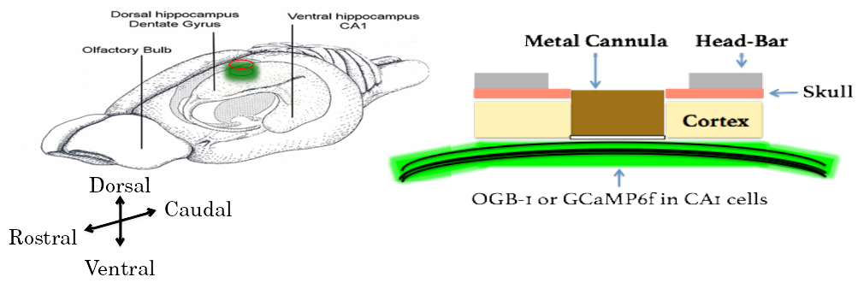

Figure : (Left) A schematic of the rodent brain, showcasing the two hippocampi, one in each hemisphere. The hippocampi lie ~1 mm (mice) below the cortical surface. (Right) The hippocampal preparation allows optical access to the deep lying hippocampal CA1 cells, relative to the skull/cortex. The CA1 cell bodies arrange in a laminar fashion, as a tight cell body layer that can be visualized by fluorescence (using either OGB-1 or GCaMP).

We first put the animal under anesthesia using a vapor chamber saturated with 3% isoflurane. Next, the animal is cheek-clamped and anesthesia is maintained using 1-2% isoflurane, provided directly to the nozzle of the animal, keeping track of ~1 Hz breathing rate and a body temperature of 35-37 ℃ (with heating pad). The animal is given a haircut and an ~5 cm circular incision is made on the scalp, revealing the skull below.

We then affix headbars and skull screws with the help of dental cement, to be able to clamp the animal post surgery on the Two-Photon Microscope.

The left, dorsal hippocampus is targeted with a 3-5 mm circular craniotomy aimed at 1.5 mm left and 2.0 mm behind bregma, carefully tearing and peeling out the Dura, to reveal the cortex.

We perform a Hippocampal Preparation, to aspirate out the cortex (part of the somatosensory cortex) under repeated washes of Cortex Buffer (see table 1 for recipe), and expose a part of the dorsal hippocampal surface.

Depending on the requirement for the preparation, viz., acute or chronic imaging, we used different sensors.

*Preparation of Cortex Buffer*

To prepare 1000 ml of cortex buffer, weigh out the required amount of the salts, NaCL, KCl, Glucose and HEPES (see table 1 for recipe) and make up the volume of the solution with Milli Q Water till about slightly less than 1000 ml. Measure the pH using a calibrated pH meter. The expected pH is slightly acidic (around 5), so use 1M NaOH (aq) to set the pH to 7.35.

Then, fill up the volume to 1000 ml and verify the pH (should not have changed). Filter the contents through a 0.22 um membrane using a vacuum filtration, and store at 6 °C.

| **INGREDIENT** | **CONCENTRATION (mM)** | **Amount (g or ml)** |
| --- | --- | --- |
| NaCl (s) | 125 | 7.31 g |
| KCl (s) | 5 | 0.373 g |
| Glucose (s) | 10 | 1.8 g |
| HEPES (s) | 10 | 2.38 g |
| CaCl2 (aq) | 2 | 1.6 ml of 1.25 M stock solution |
| MgCl2 (aq) | 2 | 1.5 ml of 1.3 M stock solution0 |

Table 1: Recipe for ready-to-use cortex buffer. The buffer is typically prepared and stored in aliquots to be used each week. The correct pH range of the buffer was often a crucial factor ensuring the success of the hippocampal preparation.

*Oregon Green Bapta-1 Injections for Acute Imaging*

For acute/single-day experiments, we injected OGB-1 using pulled, dye loaded micropipettes at a depth of 100-150 µm (Figure ) from the topmost layer of exposed tissue, till a slow but detectable pulse of dye (visualized as a red/pink solution; see table 2 for recipe) may be visible just below the tissue surface. This allows the dye to be soaked up by the basal dendrites of the CA1 and takes 30-60 mins for incorporation into the cytoplasm. We typically allow the animal 1-2 hours of respite before the subsequent imaging session. High pressure ejection of the dye into the tissue may damage the neuropil, while very low pressures or clogs in the pipette affect the spread of the dye across the tissue. We aimed to image ~100 x 100 µm2 of the tissue in any particular ROI, and achieved this with 5 minute injections with each micropipette aiming to load the dye at 2-3, well separated positions spread across the entire exposed dorsal surface. We estimate that the dye volume was <1000 nl/injection. After the injection cycle with any micropipette, we leave the tissue undisturbed for at least 5-10 mins before pulling the micropipette out of the tissue.

<Table 2 here>

Once all the injections are complete, the exposure is sealed using 5% low gelling Agarose, just before it sets, making sure the temperature is cool enough to avoid heat-related tissue damage. Place a drop of the 5% agarose solution on the back of the hand to test the temperature.

OGB-1 is eventually cleared from the cytoplasm but allows for a limited window for imaging studies (Stosiek et al.., 2003). Reopening the Agarose seal and re-injections were never attempted to prevent unnecessary damage to the underlying tissue. Additionally, the agarose plug itself was found to be unstable beyond 1-3 days. This resulted in the imaging possibility being limited to the same day as the surgery (acute imaging).

*GCAMP and Chronic Imaging*

For chronic/multi-day experiments, we standardized a stereotaxic viral injection step, where we inject the gene for GCaMP5 or GCaMP6f into the dorsal hippocampus at -1.5 mm lateral, 2 mm posterior, and 1.3 mm dorsal from Bregma on the skull surface (Figure ).

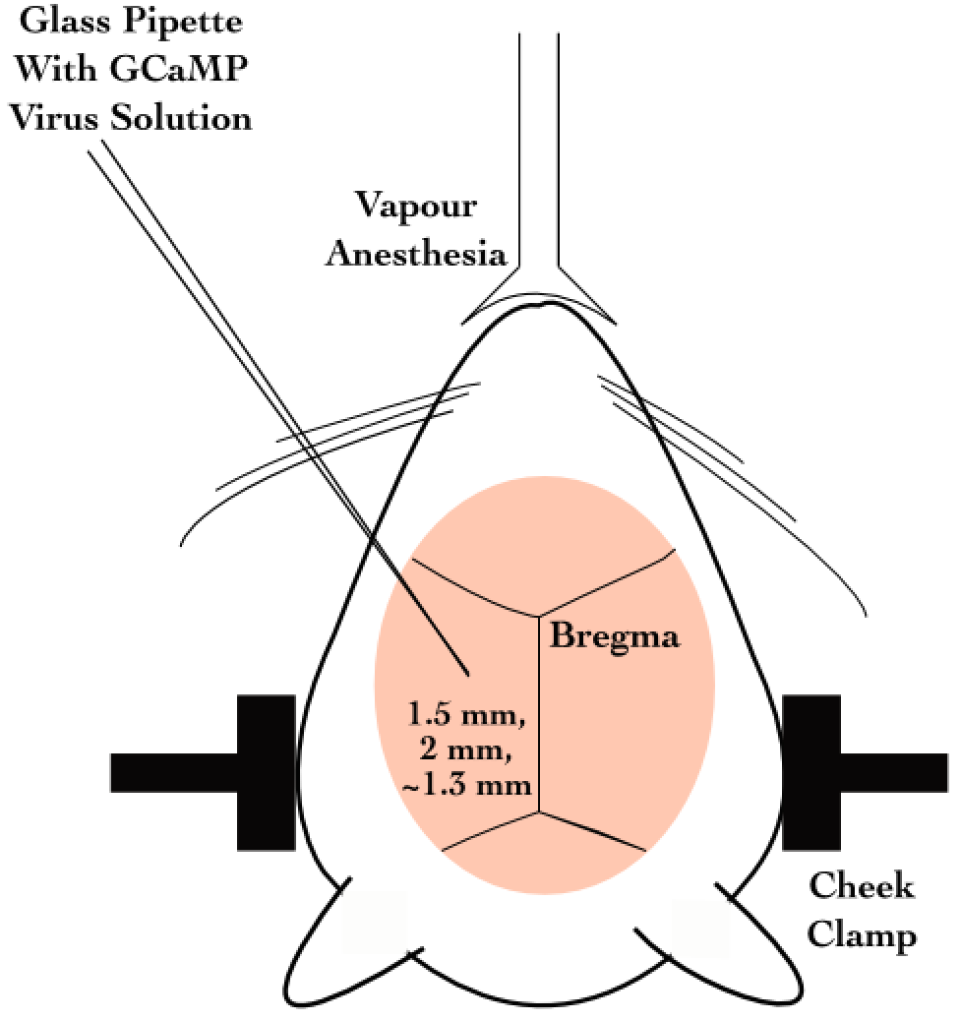

Figure : Schematic representation for stereotaxic viral injection.

Later on, we switched to directly using GCaMP6f transgenic mice (background: C56BL/6) which express GCaMP6f in the Hippocampus (Chen et. al., 2013), and thus circumvented the dye loading or viral injection steps, aiding in the potential success of the preparations, by way of tissue health and recording quality.

RESULTS

*Two-Photon Calcium Imaging of Hippocampal CA1, in vivo*

Next, we subject the CA1 cells to Imaging. The CA1 cell body layer is ~200 μm deep in through the hippocampal surface. At these depths, scattering of excitation as well as emission light is significant. However, we are able to image at these depths with Two-Photon Imaging LASER Scanning Imaging (810 nm for OGB-1 and 910 nm for GCaMP5/GCaMP6f), where a high intensity pulsed LASER allows for Two-Photons to near instantaneously excite fluorophores in a thin z-slice plane which is the focal plane of the Objective. There is scattering, but this since only the focal plane is excited any and all emitted photons that we capture are part of the signal. We use a 16x water immersion, 0.8 NA, 3 mm working distance Objective, to get a large field of view.

*Acute Imaging of OGB-1 loaded Hippocampal CA1*

OGB-1 spreads throughout the cytoplasm and neuropil, and infiltrates the cell nucleus, giving the cells the appearance of solid circles (cells). The cell body (soma) ranges from 10-15 µm depending on the orientation of the imaging layer in 3D tissue space (Figure , left).

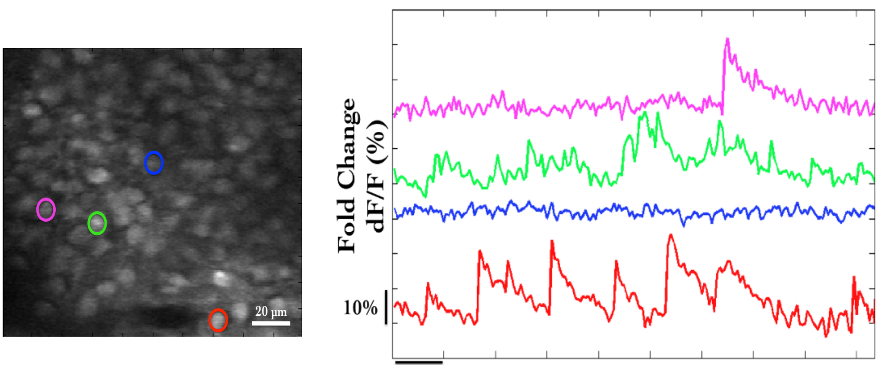

Figure : (Left) Representative Two-Photon Calcium Image of a plane of Hippocampal CA1 cells, bolus loaded with Oregon Green Bapta-1 (OGB-1), at an instant in time. Example cells marked out post-hoc as pink, green, blue and red. Scale bar 20 µm. (Right) Representative dF/F (%) traces for the calcium activity recorded in a single 10s video for example cells pink, green, blue, and red. Scale bar (1 sec; 10% dF/F).

Each cell in the recorded region of interest (ROI), is identified, marked out (in pixel identity), based on local activity of correlated pixels in the time series movies. The average intensity of the pixels corresponding to each cell for each frame in each recording video, is saved as the raw calcium fluorescence trace.

Next, these raw calcium traces are baseline normalized to equate the baselines for each cell at 0, and describe the dynamic range of the intensity values as 0 to 1, or 1 to 100%. Here are the corresponding time series of baseline normalized dF/F for the representative example cells (the same blue, green, and red cells as above) are shown below (Figure , right).

*Chronic Imaging of GCaMP expressing Hippocampal CA1*

For Chronic Imaging, tissue health was of paramount concern since it could easily degrade in time (Figure ). With practice and standardization, we were able to get the preparations to survive for 2-4 weeks at very good signal-to-noise. Preparations that resulted in very poor signal-to-noise were often recorded but have been filtered out of the data showcased in this thesis. While preparations can sometimes last even months, typically it is crucial to consider if the ROI for recording could provide >20 cells, to continue the experiment.

GCaMP is typically designed to be cytosolic and does not typically cross into the cell nucleus. GCaMP labeled cell bodies appear as doughnuts in the imaging slice Figure and Figure ).

Figure : Tissue Degradation over time. Representative Two-Photon Calcium images of a snapshot in time of the Hippocampal CA1 cell body layer on Day 1 (left) after the surgery and Day 3 (right) after the surgery.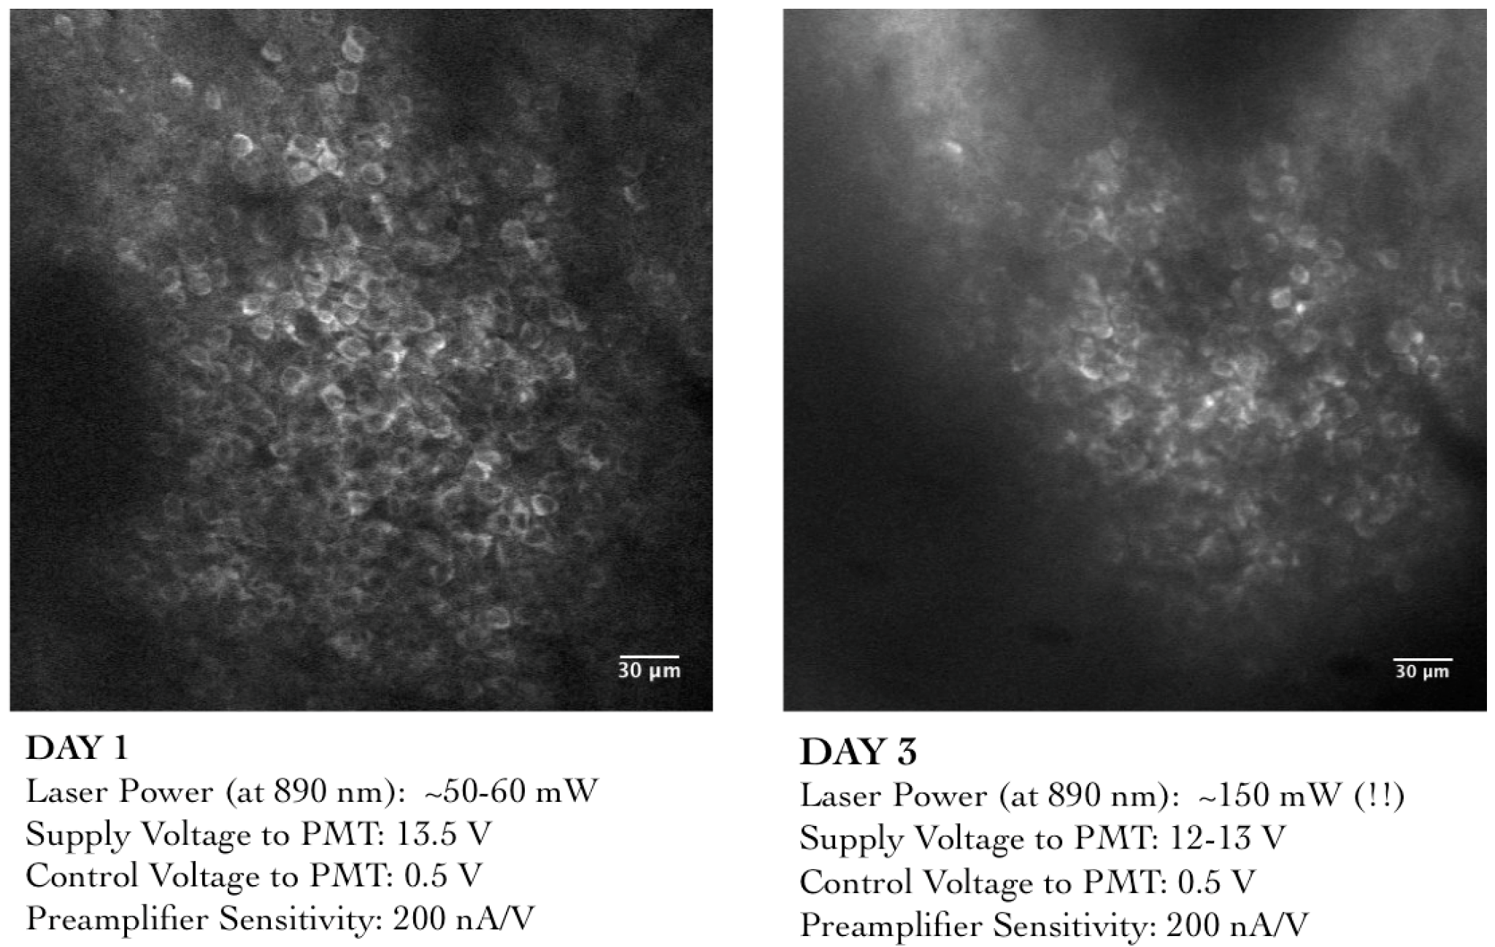

Recordings with very good signal-to-noise, where the same chronically labeled CA1 cells could be anatomically identified on subsequent days even >2-3 weeks post surgery were eventually acquired, and are featured in the data presented in Chapter 4.

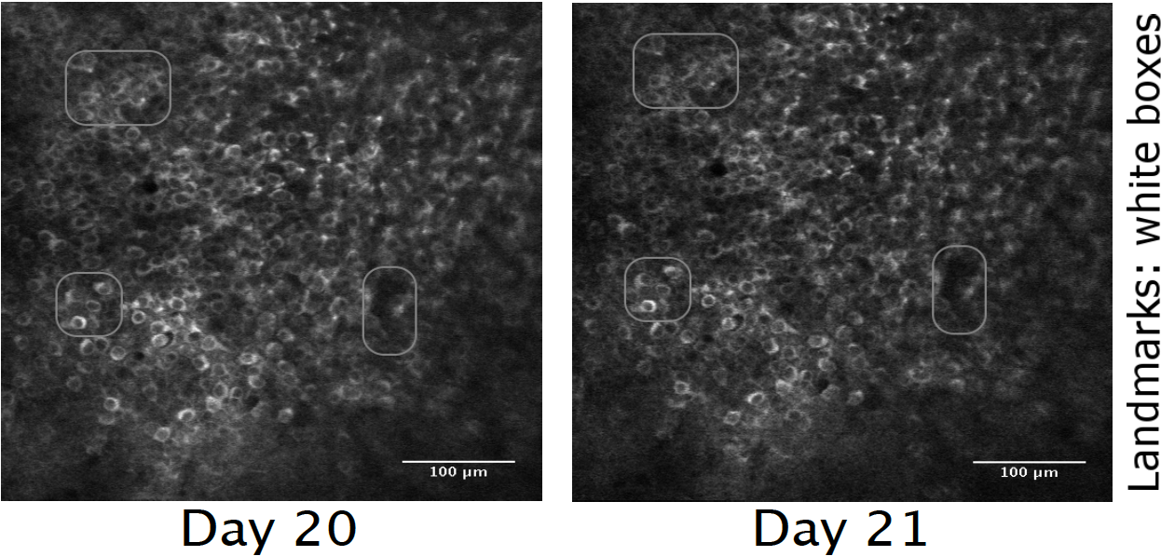

Figure : Chronic calcium imaging of the same Hippocampal CA1 cells over weeks. Landmarks have been marked and were used to confirm frame registration and identify cells.

The magnification and resolution of the field of view are important parameters to consider when balancing magnification for the resolution and the maximization of the number of cells being simultaneously recorded from (Figure ).

While recording at high frame rates for live imaging, we capture a relatively large number of cells (~100) in time-series imaging frames, at frame rates of around 10-15 fps. Subsequently, we subject the animal to various stimuli across trials and save these images for analysis.

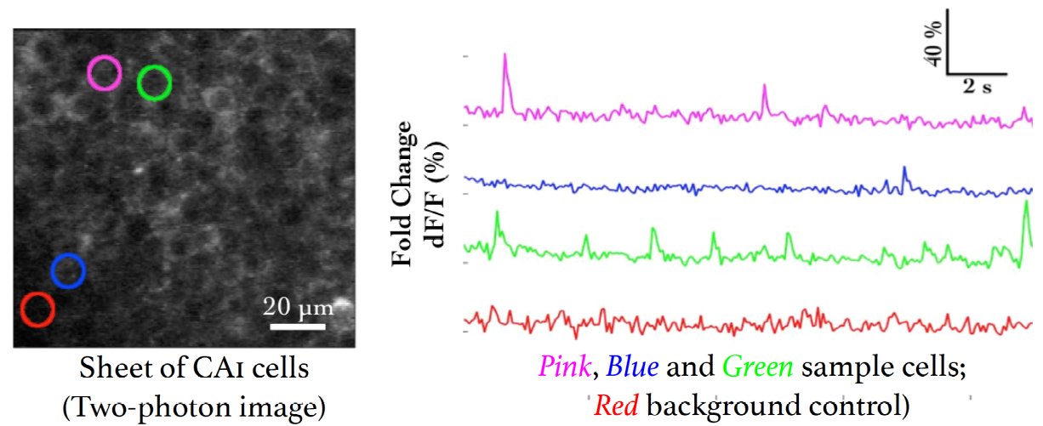

Figure : (Left) Representative Two-Photon Calcium Image of a plane of Hippocampal CA1 cells expressing GCaMP6f at an instant in time. Example cells marked out post-hoc in pink, blue, and green, with no-cell background in red. Scale bar 20 µm. (Right) Representative dF/F (%) traces for the calcium activity recorded in a single 10s video for example cells in pink, blue, and green, with no-cell background in red. Scale bar (2 sec; 10% dF/F).

*Spontaneous Activity during non-stimulus periods*

We recorded the calcium activity from a large number of Hippocampal Cells while presenting various neutral and conditioning stimuli, including fairly large periods of time before and after stimulus presentation. Activity of cells, typically observed *in vivo*, in these periods is termed Spontaneous Activity. Cells may showcase variable rate (number of calcium events per sec) and timing. Given proper signal isolation for identified cells in an ROI, each source or “cell” may be considered independent.

*Spatial organization of activity correlated cells during Spontaneous Activity*

We studied the Pearson’s Correlation Coefficient for the activity traces across all cell pairs. Cell pairs showcased a range of correlation coefficients (Figure right) and we were able to cluster cells based on activity using Meta-K Means (Modi et al.., 2014; unpublished data from Ashesh Dhawale’s Thesis).

These results matched the same published previously in the lab (Modi et al.., 2014).

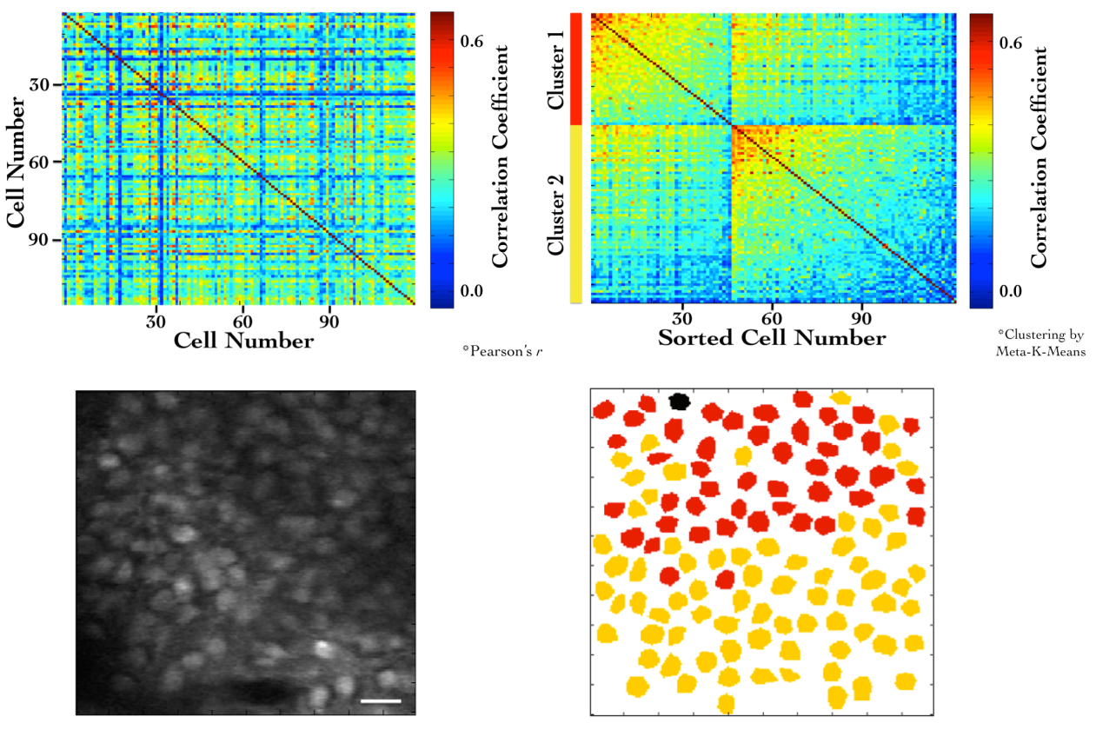

Figure : (Top left) Correlation Coefficients for cell pairs from an example two-photon recording. (Top right) Meta-K Means clustering with cell pairs using the heuristic that within group pairs would be more similar than between group pairs. In this example, the cells were clustered into two groups (red and yellow). (Bottom left) Two-Photon image of the field of view of cells. Scale bar 20 µm. (Bottom right) Spatial organization of correlated cell-pair groups (Modi et al.., 2014).

*Stimulus evoked responses*

We also recorded calcium activity from the same cells during presentation of various neutral stimuli to the animals. Here are the results of the auditory (tone) and somatosensory (whisker) stimulus experiments.

A neutral auditory tone at 5000 Hz (for 1 sec) was presented to the animals N= 6 animals; 25 trials). We observed no clear signs of cell activity modulation by neutral tones. Below, we show an example animal with trial-averaged calcium traces as dF/F (%), across all recorded cells with a 1 sec tone presentation (Figure , left). We also presented animals to whisker stimulation by playing a 1s long air-puff (5 LPM) to the ipsilateral (left) whisker (N = 5 animals; 25 trials). In this case, we observed whisker-stimulation based cell activity modulation. Below, we show the trial-averaged calcium traces as dF/F (%) of the same example animal as above, presented with a 1 sec whisker-puff (Figure , right).

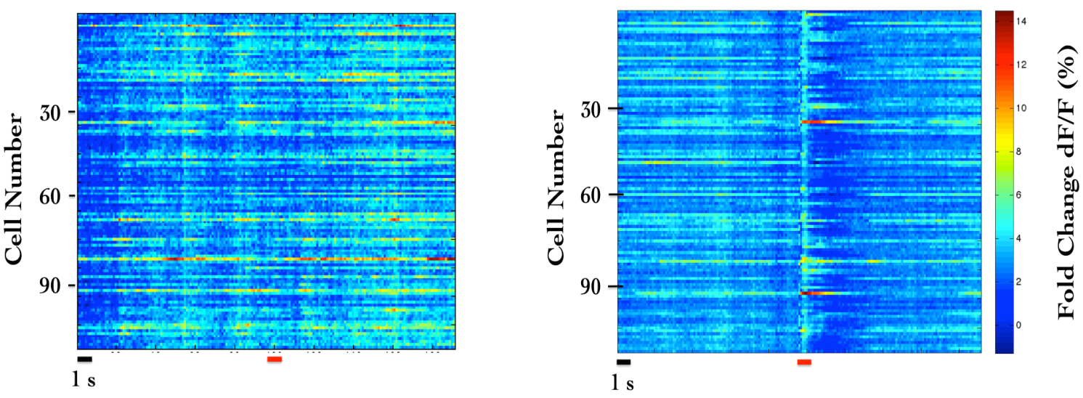

Figure: (Left) Trial-averaged (25 trials) calcium activity from ~100 CA1 cells in trials where a 5000 Hz tone was presented (red bar). (Right) Trial-averaged (18 trials) calcium activity from the same cells in trials where a 5 LPM air-puff to the ipsilateral whiskers was presented (red bar).

More short-range localized clustering of groups of cell-pairs with correlated activity were observed post whisker-stimulation.

* ***- Results from chronic imaging - -***

The need for multi-day tracking was mandated for recordings through behavioural training, since the animals typically only learn Trace Eye-Blink Conditioning (TEC, Chapter 2) over the course of 3-7 days (Siegel et al.., 2015). A different experiment design would have been to train animals and then perform the hippocampal preparation to record CA1 neural activity while the animal(s) exhibit learnt Conditioned Responses (CRs). However, we argued against this experimental design, on account of the following.

1. The actual cellular and network mechanisms that allow for the animal to learn the behavioural task would be very difficult to study given that the learning period would have passed.
2. The success rate of the hippocampal preparation is typically very low, while TEC is typically learnt by >50% animals (Modi et al., 2014; Siegel et al., 2015). We had argued for exposing the hippocampus for imaging before behavioural training since any successful preparations could then be subjected to the relatively more consistent behavioural training.
3. Having the preparation performed before training minimizes the number of times the animal would be subjected to surgery (to just the once), improving chances of animal health through the experiment.

Next, we discuss some preliminary results from the chronic imaging datasets. A non-overlapping set of results that feature in “Chapter 4 - Analysis” of this thesis, have been skipped here for brevity.

*[Legacy] Analysis to Identify Time Cells*

The analysis algorithm pertaining only to the results presented here in “Chapter 3 - Imaging”, was adapted from William Mau’s Temporal Information method (Mau et al., 2018; “Chapter 4 - Analysis”). This analysis algorithm was not developed to the extent of the Python/C++ implementation featured in “Chapter 4 - Analysis” and is expected to be subject to some degree of Type I (false positives) and Type II (false negative) errors.

1. Filter to select for cells that had activity in >25% of trials (irrespective of tuning)

2. Develop Event Time Histograms, using Area Under the Curve for a binsize of 3 frames, centering the “0 ms” to the onset of the Conditioned Stimulus for visualization.

3. Estimate Temporal Information (TI), using

TI = 1/λ * Σj λj log2 (λj / λ) Pj

where, λ is the Average Transient rate for each cell

… read avgAcrossTrials(AOCtrial)

λj is the Average transient rate for each cell in bin “j”

… read avgAcrossTrials(AOCi) for each bin “j”

Pj is the Probability that the mouse was in time bin “j”

4. For every trial, random shuffle the frame points to develop a random activity model (1000 times) and ensure that λ > λrand in more than 99% of the models. If yes, then the cell has time locking with temporal information (TI; in bits) as a measurement for time information. Filtering for cells active in >25% trials with a λ > λrand in >99% shuffles, along with the estimation of TI, provide us a handle on reliability.

*Time Cells*

During the experience of temporally organized events or stimuli, in this case post training to Trace Eye-Blink Conditioning, a rough contingent of ~20% of the total cells recorded, were observed to showcase time-locked calcium activity mapping the Blue LED or Conditioned Stimulus (CS) to the airpuff or Unconditioned Stimulus (US). These cells were classified as Time Cells. Here are some example Time Cells (Figure ).

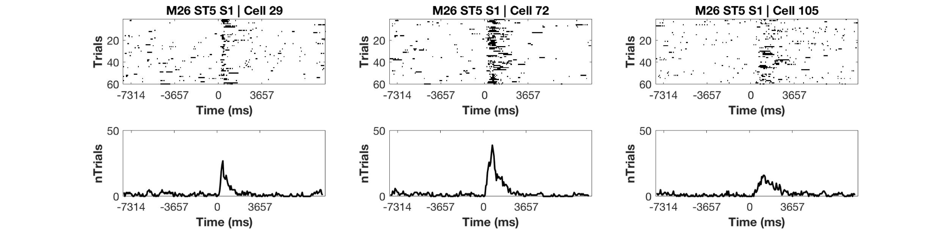

Figure : Example Time Cells visualized as event raster plots (upper row), along with the trial-summed activity profiles (lower row) suggesting ~50% hit trials, for cells 29 and 72 from Session 1 (session type 5) with mouse M26, and slightly lower reliability (~25% hit trials) from cell 105.

*Other Cells*

On the other hand, most cells did not clear our analysis algorithm checkpoints and were classified as Other Cells. Here are some example Other Cells (Figure ) from the same session with mouse M26 (Session 1; session type 5).

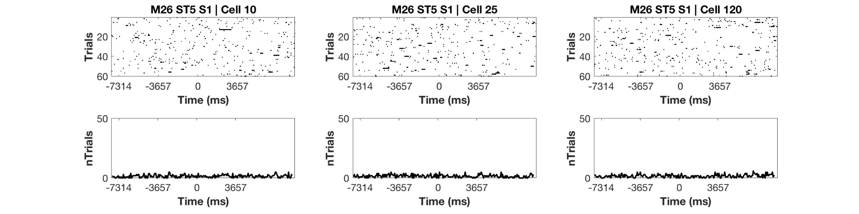

Figure : Example Other Cells visualized as event raster plots *(upper row)*, along with the trial-summed activity profiles *(lower row)* for cells 10, 25, and 120 from Session 1 (session type 5) with mouse M26.

Considering only the classified Time Cells, we sorted cells based on the time of the peak of the trial-average activity and a spatiotemporal sequence was visualized (Figure ;also see “Chapter 4 - Analysis Figure 7H”).

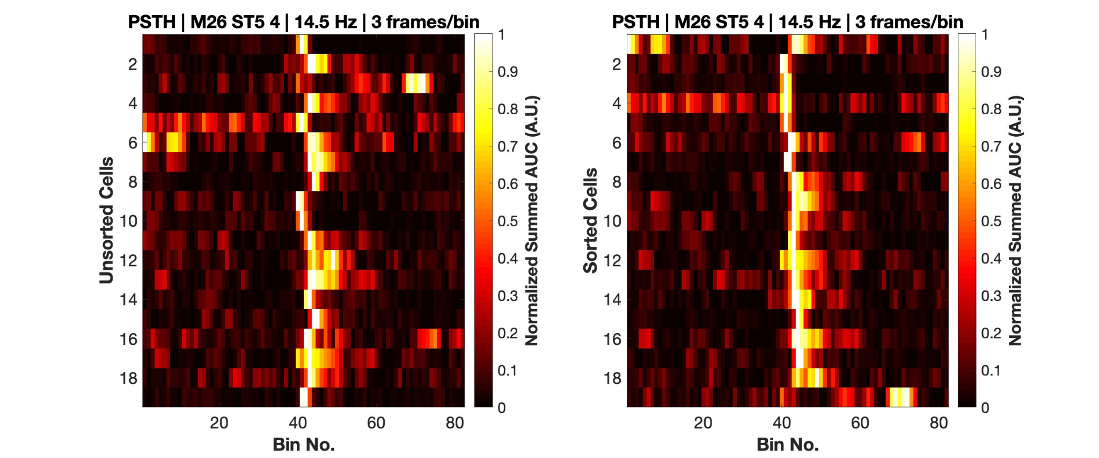

Figure : Event Time Histograms or tuning curves for Identified Time-Locked Cells with trial-summed peaks in session 4 of training (session type 5) with mouse M26. (*Left)* Unsorted list of Time cells. *(Right)* Peak-sorted list of the same cells. Here, 1 bin = 3 frames = ~210 ms (sampling rate 14.5 Hz without binning; ~5 Hz with binning). As per the (legacy) session type 5 protocol, the CS (50 ms Blue LED flash) was presented in frame bin 39 a conservative stimulus-free trace interval during frame bins 40 and 41, and the US (50 ms airpuff to ipsilateral eye) presented in frame bin 42.

We did not observe any obvious trend in the temporal information of Time Cells with peak times. For the same cells as in Figure , we now look at the actual Temporal Information estimates (Figure ).

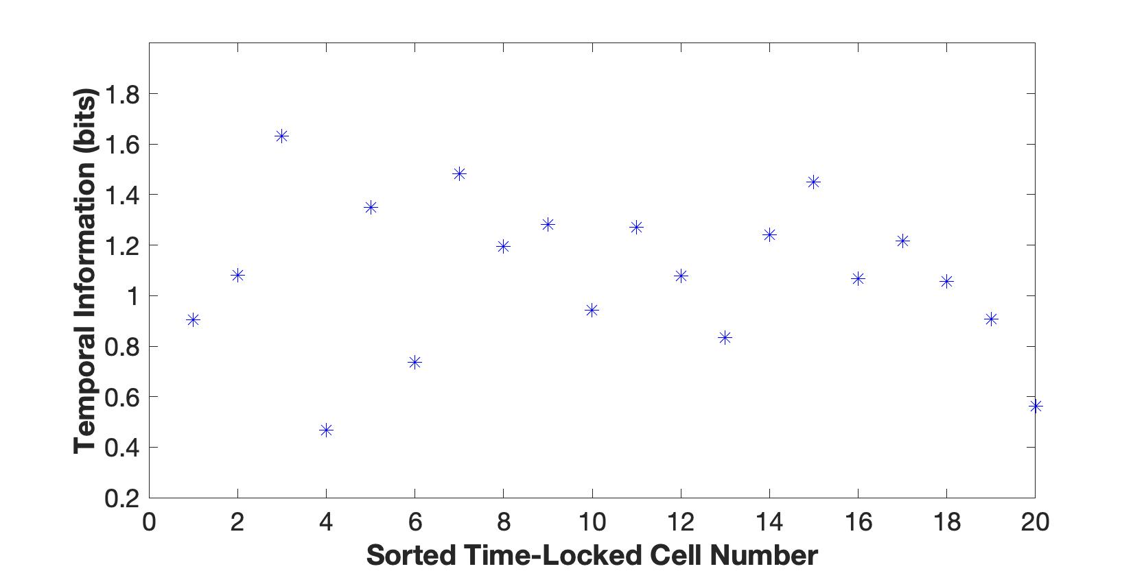

Figure : Temporal Information (bits) vs Sorted Time Cell number from the analytically identified Time Cells in Session 4 (session type 5) with mouse M26. No clear trend was observed.

*Tuning, retuning, and detuning of Time Cells across sessions*

A crucial advantage of the chronic preparation was that many anatomically aligned and classified cells (as cell ROIs), could be recorded from over several days and sessions, to look for possible changes in calcium activity profiles across sessions in the same set of cells.

We noticed some evidence for an expansion of the set of identified Time Cells with sessions, up to a reliable pool of ~20% Time Cells. Altogether, from the pool of chronically aligned cells (across sessions), there was an increase from 7.7% to 23.1% of Time Cells. Considering the full cohort cells (irrespective of tracking across multiple training sessions) the increase was from 7.2% to 21.1% Time Cells. Here are the classified Time Cells between two independent recording sessions, early in training.

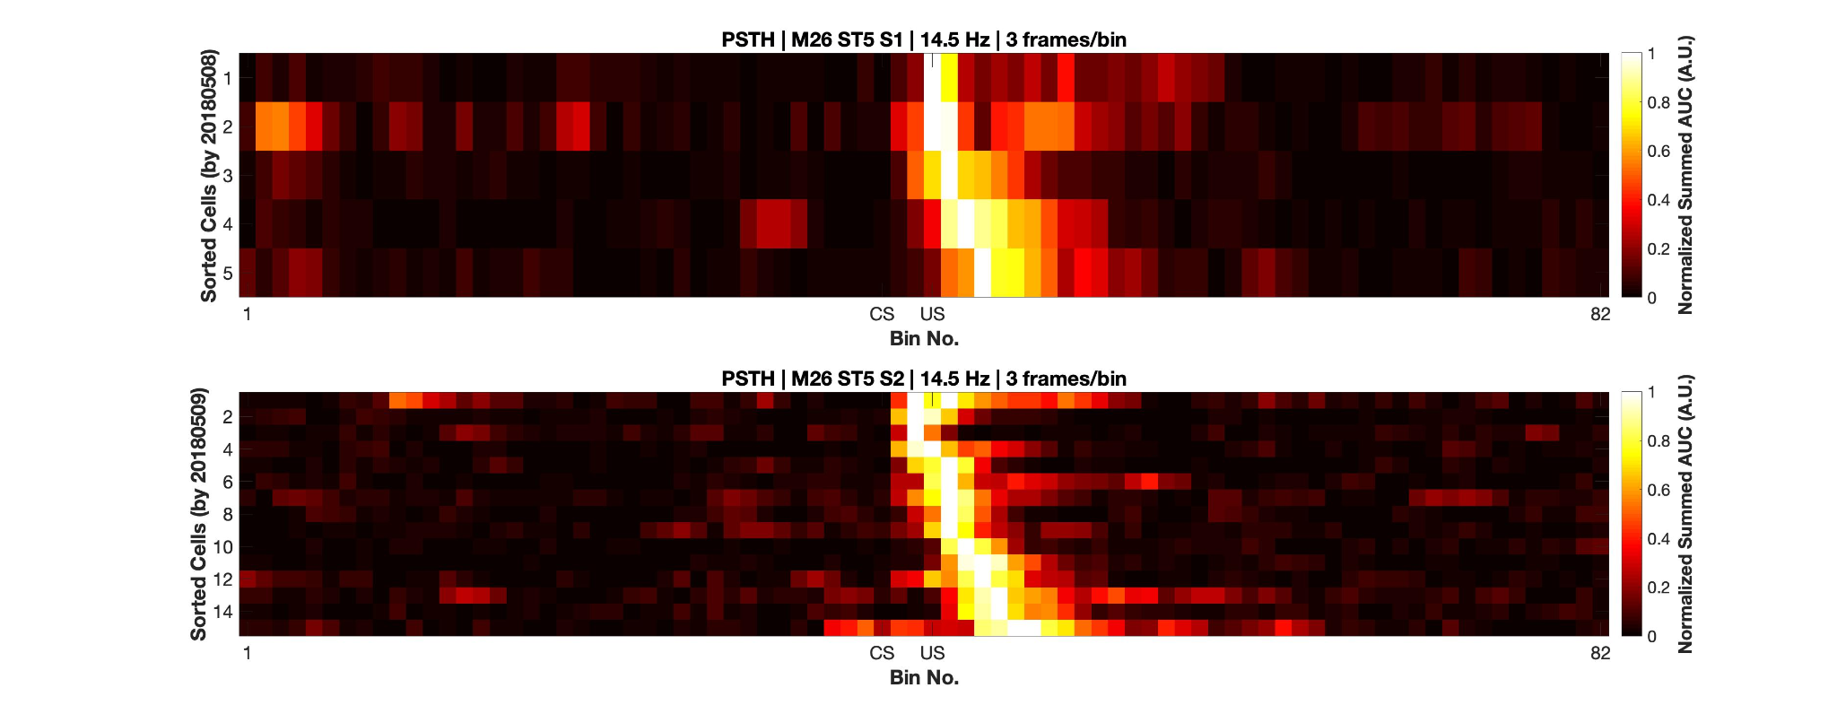

Figure : More time cells observed to attain tuning as training sessions. Event Time Histograms of the identified set of time cells between sessions 1 (up) and 2 (below) with mouse M26 (session type 5).

The same may also be visualized as trial-averaged calcium activity profiles for all recorded cells across independent recording sessions (Figure ).

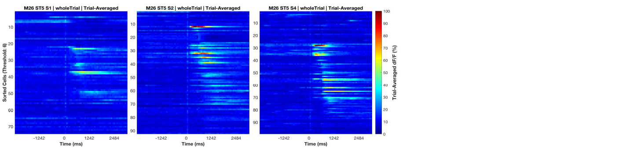

Figure : Sorted Time Cells form Sequences that develop with learning. Trial-Averaged calcium activity traces for all recorded cells across sessions 1, 2, and 4 (session type 5) with mouse M26. Time 0 ms was aligned to the CS. The CS + Trace + US interval lasted from 0-600 ms, here.

Chronically tracked Time Cells that showed reliable tuning across sessions were then compared to look for any shifts in the peak tuning bin.

We observe examples of cells that maintained their tuning across pairs of sessions (Figure ).

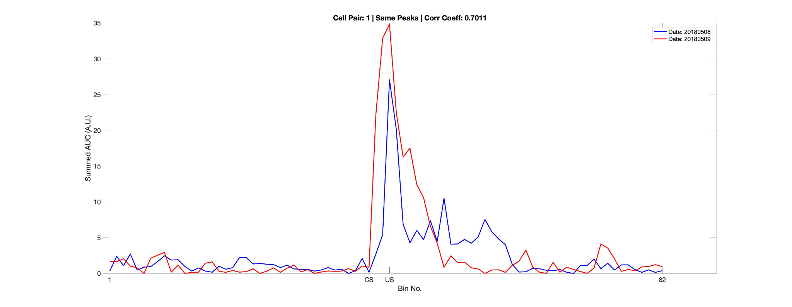

Figure : Same/similar tuning across session 1 and session 2 for this example Time Cell. *Blue* Event TimeHistograms represent the tuning curve for the cell for session 1 (date: 20180508) and *Red* represent the same but for session 2 (date: 20180509). Pearson’s correlation coefficient between the two session pairs was 0.7011.

Here are examples for earlier Event Time Histogram (tuning curve) peaks across sessions (Figure ) for Mouse M26, session type 5, session 1 vs 2.

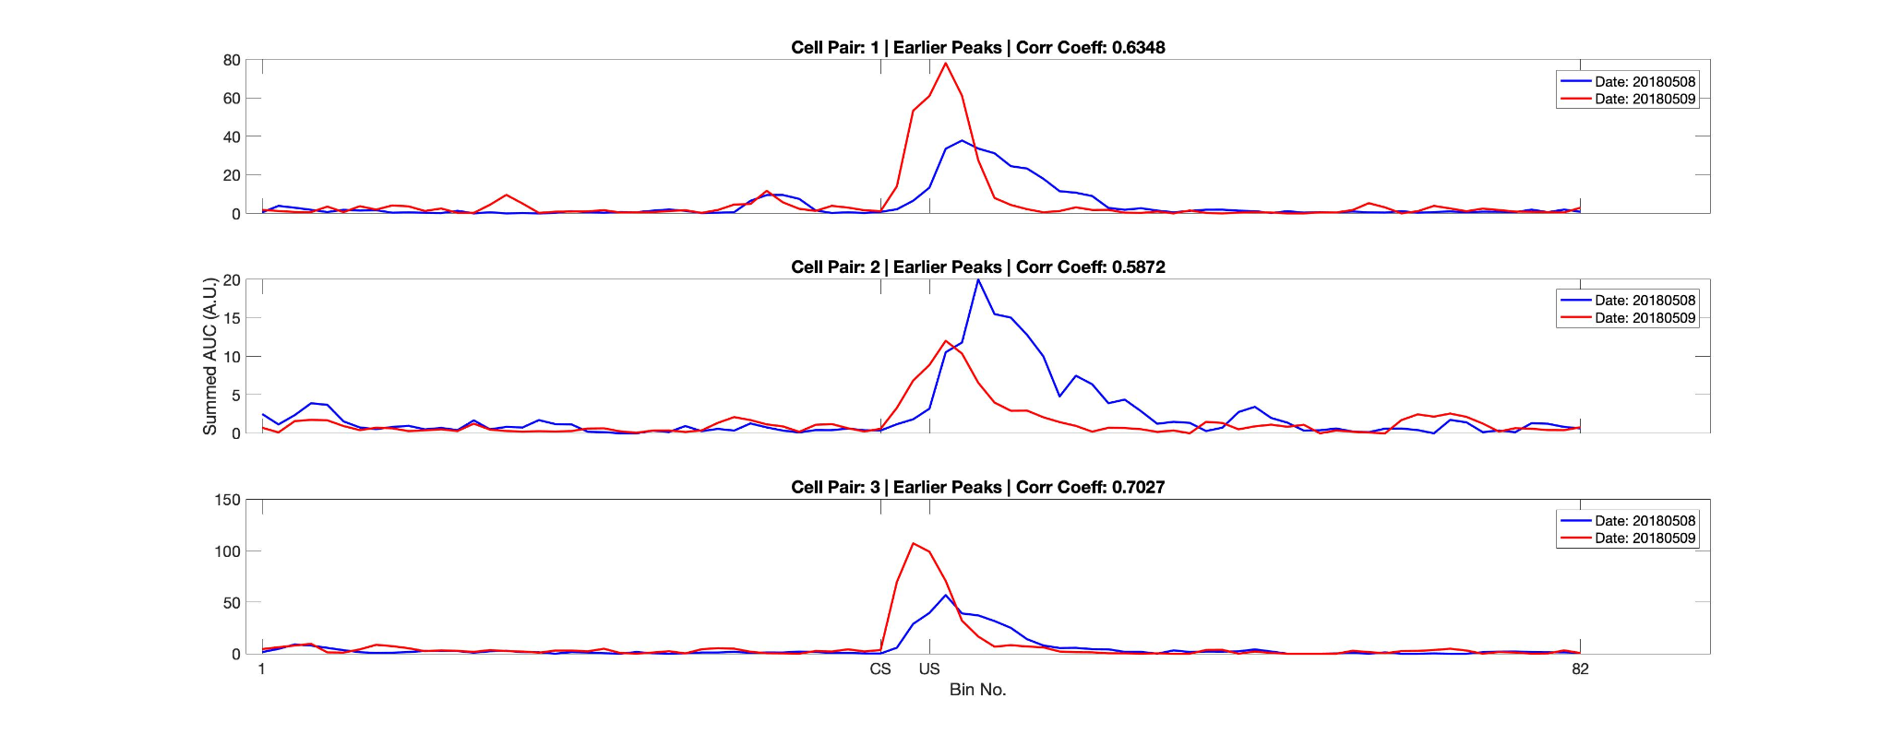

Figure : Three example chronically tracked cell pairs with tuning peaks arriving earlier with training sessions *(rows)*. *Blue* Event TimeHistograms represent the tuning curve for any cell for session 1 (date: 20180508) and *Red* represent the same but for session 2 (date: 20180509). Pearson’s correlation coefficient between the session pairs was 0.6.348, 0.5872 and 0.7027 for cell pairs 1, 2 and 3, respectively.

Here is an example of a cell showcasing detuning across sessions.

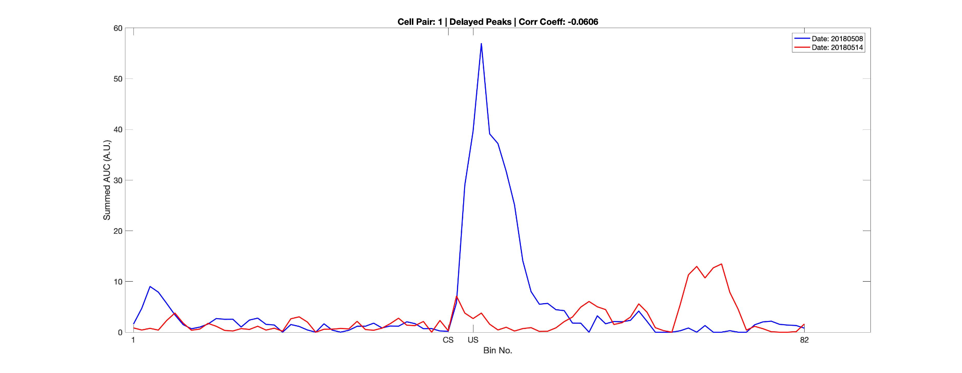

Figure : Example chronically tracked cell pair with detuning between session 1 and 4. *Blue* Event Time Histograms represent the tuning curve for the example cell for session 1 (date: 20180508) and *Red* represent the same but for session 4 (date: 20180514). Pearson’s correlation coefficient between the two curves was -0.0606.

A full summary of the correlation based peak timing analysis for chronically Time Cells with mouse M26 are shown (Figure ). Across all same cell pairs, there was positive correlation (>0.2) in 71% of Time Cells. Also a comparison of the tuning curve peaks between the same Time Cell pairs revealed that a majority of the retuned peaks occurred earlier in time, going across sessions (71%), with an equal proportion of cells without much retuning (14%) or retuning to later time points (14%).

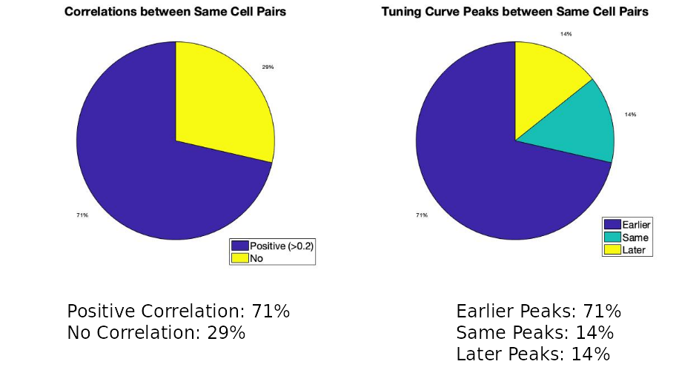

Figure : Comparing time cells across sessions for all cells.

An essential summary of the key preliminary results observed using real physiology data were:

1. Time Cell tuning curve peaks typically began only after the presentation of the CS.
2. The width of the tuning curve peaks for Time Cells increased with tuning to later frame bins. This was consistent with the recordings presented in literature under physiological conditions (Pastalkova et al., 2009; MacDonald et al., 2011; MacDonald et al., 2013; Modi et al., 2014; Kraus et al., 2015; Mau et al., 2018).
3. Pairwise Time Cell tuning curves for different Time Cells may have some overlap in timing, but peaks were observed in all frame bins between the CS and the US. This particular observation is confounded by the short number of Trace period frames recorded and the requirement to consider 3 recording frames to every bin (Mau et al., 2018), decreasing the effective sampling rate even further (14.5 Hz without binning, to ~5 Hz with binning). Further experiments may be necessary to interpret. However the observation is still consistent with previous literature (Pastalkova et al., 2009; MacDonald et al., 2011; MacDonald et al., 2013; Modi et al., 2014; Kraus et al., 2015; Mau et al., 2018).
4. A surprisingly large number of Time cells could be identified with tuning peaks for frame bins occurring after the termination of the US.
5. Considering all chronically tracked cells, the classified and sorted Time Cells formed sequences that were dynamic across learning sessions. Many Time Cells developed tuning curves with sessions while some Time Cells lost their tuning.
6. For the majority of Time cells, retuning occurred with initial tuning to the timing of the US in earlier sessions, followed by a shift to earlier time points for the tuning peak, as training progressed through sessions.

Future directions to be explored in the lab include studying the reliability of a larger pool of chronically tracked cells with switches in the Inter-stimulus Interval (ISI) between the CS and the US as well as with a larger palette of different stimuli testing out a battery of Conditioned Stimuli (CS1, CS2, etc.) and Unconditioned Stimuli (US1, US2, etc.). The goal is to understand how well the internal neural spatiotemporal CA1 sequence maps to the external behavioural protocol parameters, *in vivo*.

– Bibliography